**SWE 599 Project, Fall 2015**

**Supervisor: Fatih ALAGÖZ**

**Project Safe Send**

**Requirements Specifications Document**

**02.11.2015**

**Revision 1.0**

**By: Nuri Emre GÜRER**

Table of Contents

Revision History 3

1. Introduction 4

2. Requirements List 4

3. Non-functional Requirements 4

4. Overall Use Case Diagram(s) 5

5. Use Case Descriptions 5

6. Mockups 7

7. References 8

# Revision History

|  |  |  |
| --- | --- | --- |
| **Revision** | **Date** | **Explanation** |
| 1.0 | 02.11.2015 | Initial requirements based on problem definition details and meetings with client. |

# 1. Introduction

The purpose of this project is to develop an iPhone application which sends photos or videos to another user with the desired level of encryption.

The application functions and user interface details are given in the following section of this document.

# 2. Requirements List

The following table comprises a mapping between requirements list and use cases, it explores which use cases provide the functionality of each requirement.

|  |  |  |
| --- | --- | --- |
| **No** | **Requirement** | **Use Case** |
| 1 | Sender and receiver will be able to register to the system. | Register |
| 2 | Sender and receiver will be able to sign-in to the system. | Sign in |
| 3 | Sender will be able to list the contacts. | List Contacts |
| 4 | Sender will be able to send photo or video with the desired level of encryption. | Send Photo or Video |
| 5 | Receiver will be able to receive and decrypt the photo or video and display it. | Receive Photo or Video |
| 6 | Sender and receiver will be able to see the transfer history. | History |

# 3. Non-functional Requirements

1. The system should be able to run on iOS environment.
2. The application should be written in Swift programming language.

# 4. Overall Use Case Diagram(s)

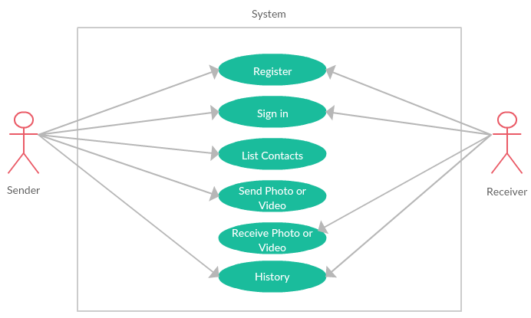

# 5. Use Case Descriptions

|  |  |
| --- | --- |
| **Use Case** | Register |
| **Description** | Sender and receiver will create an account by their name, surname, email address and a password. The application will get the phone number of the user automatically and save it on the database. The length of the password at least should be 8 and should contain 1 upper case, 1 lower case and 1 special (!#+%&/*-_,.) character. |
| **Actors** | Sender, Receiver |

|  |  |
| --- | --- |
| **Use Case** | Sign in |
| **Description** | Sender and receiver will log in to the system with their email address and password at the first time. The application will remember the user and automatically log in the user next time. |
| **Actors** | Sender, Receiver |
| **Use Case** | List Contacts |
| **Description** | Sender will display the list of contacts. The items of the list will be from the address book of the iPhone who is using the application. |
| **Actors** | Sender |

|  |  |
| --- | --- |
| **Use Case** | Send Photo or Video |
| **Description** | The sender will select the receiver from the contact list. After selection, sender will select photo or video from the album. There will be 3 levels of encryption: normal, secure, highly secure. The encryption algorithm will change according to the selection of the sender. The photo or video will be sent to the receiver with the selected encryption level. |
| **Actors** | Sender |

|  |  |
| --- | --- |
| **Use Case** | Receive Photo or Video |
| **Description** | The receiver will receive the photo or video when the application is online. Data will be decrypted according to the selected level by the sender. |
| **Actors** | Receiver |

|  |  |
| --- | --- |
| **Use Case** | History |
| **Description** | The sender and the receiver will be able to see the transfer history. The history list will contain the direction of the transfer such as “from” or “to”, the name of the contact and the date of transfer. The list will be in the descending order according to transfer date. |
| **Actors** | Sender, Receiver |

# 6. Mockups

|  |  |  |
| --- | --- | --- |
| **Welcome** | **Register** | **Login** |
|  |  |  |
|  |  |  |
| **Contact List** | **Send Photo** | **History** |
|  |  |  |

# 7. References

[1] Bennett-Object-oriented System Analysis and Design using UML 4thE

[2] <http://www.uml.org/>